Year 9 Physical Sciences

Test Questions

If a metal rod is placed in a fire, heat travels along it by …

convection.
insulation.
radiation.
conduction.

Although aluminium is a good conductor of heat it can still be used to insulate houses because it …

reflects heat.
conducts heat.
radiates heat.
absorbs heat.

Which of the following is an example of convection of heat?

Smoke from a fire always rises up over the fire.
Many stainless steel saucepans have aluminium bases.
Solar hot water systems on a roof are painted black.
Electric heaters have silver coloured reflectors behind the elements.

If you sit on the edge of a swimming pool and dangle your leg in the water, your leg appears to bend where it enters the water. This is because of a behaviour of light called …

diffuse reflection.
refraction.
regular reflection.
absorption.

In which of the following does sound travel at the lowest speed?

Water.
Air.
Metal.
Wood.

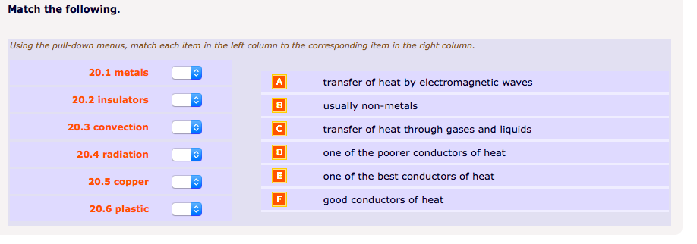
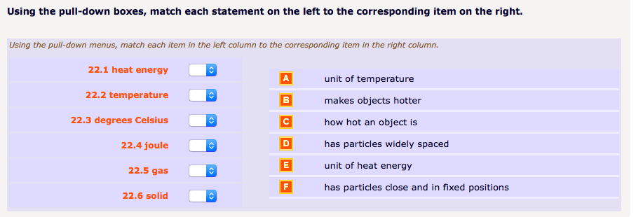

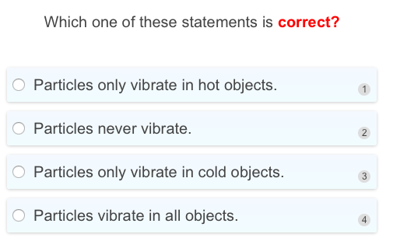

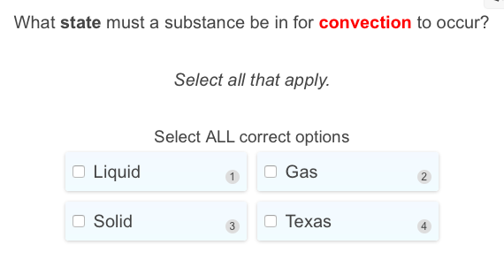

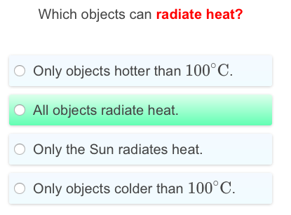

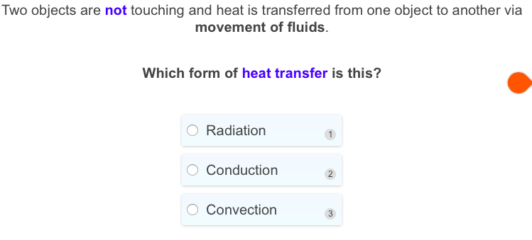

- When water is heated its molecules move faster and
  - (a) energy is tranferred as molecules vibrate and collilde with each other.
  - (b) heat is transferred by means of mass movement of molecules.
  - (c) heat energy is radiated evenly throughout the liquid
  - (d) they get bigger

- Which one of the following statements about heat transfer is correct?
  - (a) convection is the process of heat transfer through liquids only
  - (b) conduction is the process of heat transfer through metals only
  - (c) radiation requires no material medium for the transfer of heat
  - (d) radiation will not occur through a vacuum

Two similar cars, one painted black and the other white, were parked side by side in the early morning and the temperature inside each was measured every 15 minutes.
Which of the following graphs in figure 2. shows how the temperature inside each car changed?

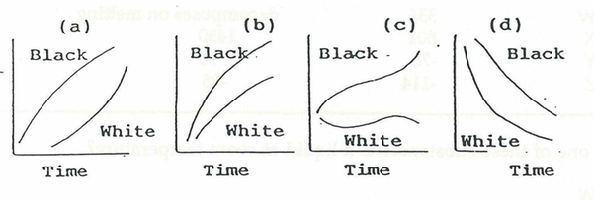

If one end of a copper rod is held in a gas flame, heat travels quickly along the bar to the other end. Substances like copper which behave in this way are called
- (a) reflectors
- (b) insulators
- (c) radiators
- (d) conductors

Two cans were filled with equal amounts of boiling water. One can was black, the other silver. Explain why your suggested can cools faster (in terms of radiation and heat loss).
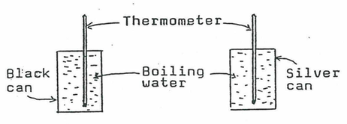
Which can would cool faster? Explain why one can cools faster than the other .
(2 marks)

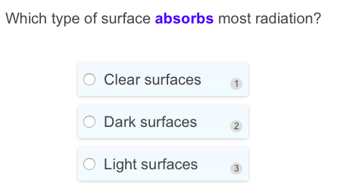

Which of the following statements best describes a wave?
 | A | A wave transfers energy to vibrating particles that then return the energy to the source.
 | B | A wave transfers energy into a material by vibrating the particles in the material.
 | C | A wave transmits energy through a material by moving particles from one place to another.
 | D | A wave transmits energy through a material with no overall movement of matter.

Correct answer is:
 | D | A wave transmits energy through a material with no overall movement of matter.

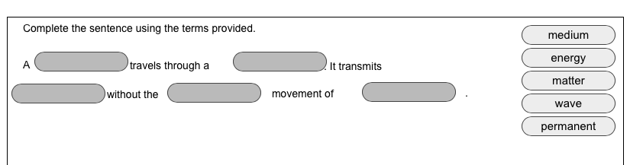

Which of the following statements best describes the motion of particles in a transverse wave?
 | A | The particles vibrate parallel to the direction of energy transfer.
 | B | The particles vibrate at right angles to the direction of energy transfer.
 | C | The particles gradually spread out parallel to the direction of energy transfer.
 | D | The particles gradually spread out at right angles to the direction of energy transfer.

Correct answer is:
 | B | The particles vibrate at right angles to the direction of energy transfer.

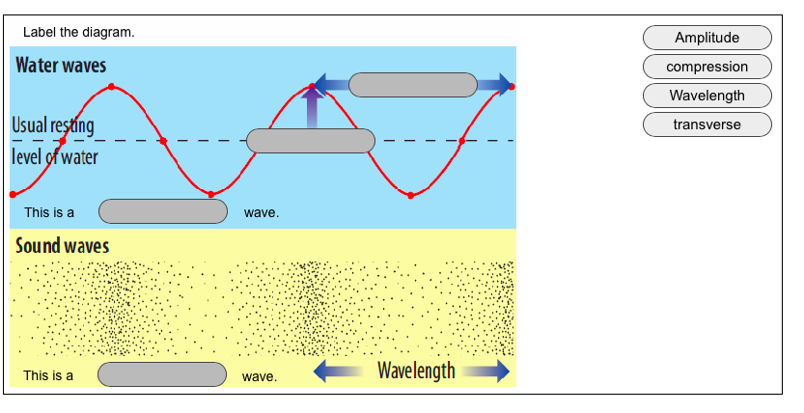

Which of the following options has the same meaning as a ‘compression wave’?
 | A | A vibration wave
 | B | An elastic wave
 | C | A longitudinal wave
 | D | A transverse wave

Correct answer is:
 | C | A longitudinal wave

Which of the following statements best describes the image formed in a plane mirror?
 | A | The same distance behind the mirror as the object is in front; enlarged.
 | B | The same distance behind the mirror as the object is in front; smaller.
 | C | The same distance behind the mirror as the object is in front; upright.
 | D | The same distance behind the mirror as the object is in front; upside down.

Correct answer is:
 | C | The same distance behind the mirror as the object is in front; upright.

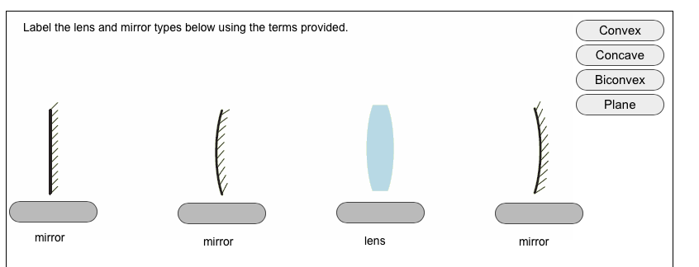

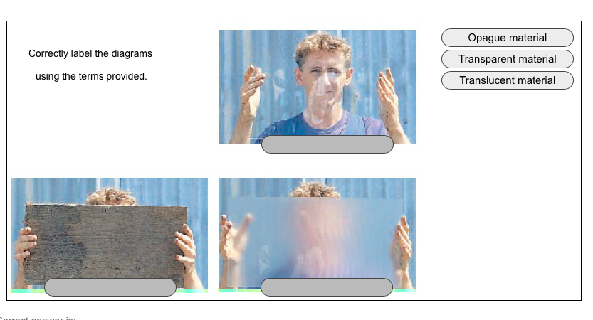

Which of the following best describes heat?
 | A | Heat is a measure of the temperature of a body.
 | B | Heat is the energy gain of a body due to friction.
 | C | Heat is energy moving from a region at high temperature to a region at low temperature.
 | D | Heat is a measure of the thermal energy in a body.

Correct answer is:
 | C | Heat is energy moving from a region at high temperature to a region at low temperature.

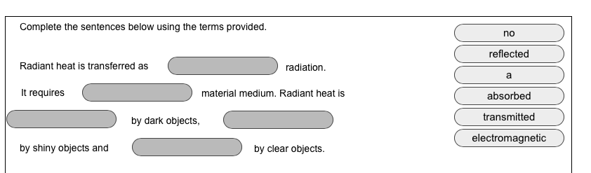

Which of the following best describes the meaning of conduction of heat?
 | A | It is the transfer of heat due to the movement of groups of energetic particles.
 | B | It is the transfer of heat due to collisions between neighbouring vibrating particles.
 | C | It is the transfer of heat due to the emission of infra-red radiation.
 | D | It is the transfer of heat due to the flow of electrons.

Correct answer is:
 | B | It is the transfer of heat due to collisions between neighbouring vibrating particles.

Which of the following lists liquids, gases and solids in increasing order of heat conductivity?
 | A | Solids; liquids; gases
 | B | Liquids; solids; gases
 | C | Solids; gases; liquids
 | D | Gases; liquids; solids

Correct answer is:
 | D | Gases; liquids; solids

Which of the following best describes the meaning of convection of heat?
 | A | The transfer of heat by particles moving away from a warmer region to a colder one.
 | B | Warm air moving sideways away from a heater.
 | C | More energetic particles moving further than less energetic ones.
 | D | The transfer of heat due to fast moving particles knocking their neighbours away.

Correct answer is:
 | A | The transfer of heat by particles moving away from a warmer region to a colder one.

An electric hot water service uses a heating element in the water storage tank. Which of the following best describes where the heater should be placed?
 | A | At the top of the tank, so that the hot water circulates to the bottom.
 | B | In the middle of the tank, so that it heats the top and bottom halves equally.
 | C | In the middle of the tank, so that conduction is most efficient.
 | D | At the bottom of the tank so that the hot water will rise.

Correct answer is:
 | D | At the bottom of the tank so that the hot water will rise.

Which of the following is not a property of radiant heat?
 | A | It travels in air at the same speed as light.
 | B | It is a form of electromagnetic radiation.
 | C | It is transferred by fast moving particles.
 | D | It can travel through a vacuum.

Correct answer is:
 | C | It is transferred by fast moving particles.

